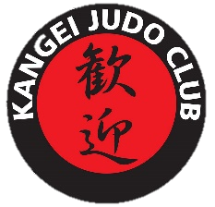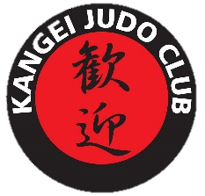

k

**Kangei Club News**

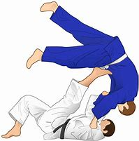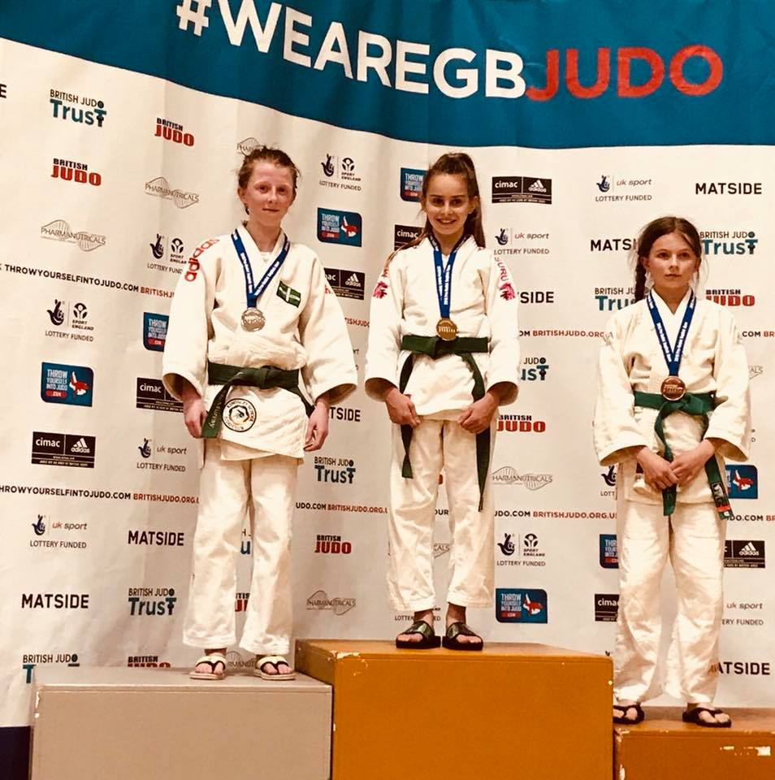

**Nage-No-Kata**

**Katame-No-Kata**

**Gold!**

**English Open Pre-Cadet Championships** took place on Saturday 28th April 2018. Izzy Dowson Competed in the U36kg category and took a gold medal becoming English Champion for the 2nd time in two consecutive years. Congratulations.

Sensei Steve Barteluk and Sensei Grant Egleton attended a Kata Course this month in preparation for their Kata Examination for their Level 1 Kata Certification. They took the exam on Sunday 29th April 2018 and passed with flying colours. They were praised by the examiner who stated that with a little tweaking they would be ready for their level 2 certification and asked them to start competing at Kata Competitions.

**Camping**

Please make sure you have paid in full for camping by Wednesday 30th May. If you are swimming, please ensure you have chosen either the family or Adult Swim

**Sausage Sizzle**

Kangei Judo Club will be at Bunnings Warehouse London Road, Basildon SS16 4PR on 13th May 10am – 4pm. This will be to help raise money for a potential new permanent Dojo.

**Anouncements**

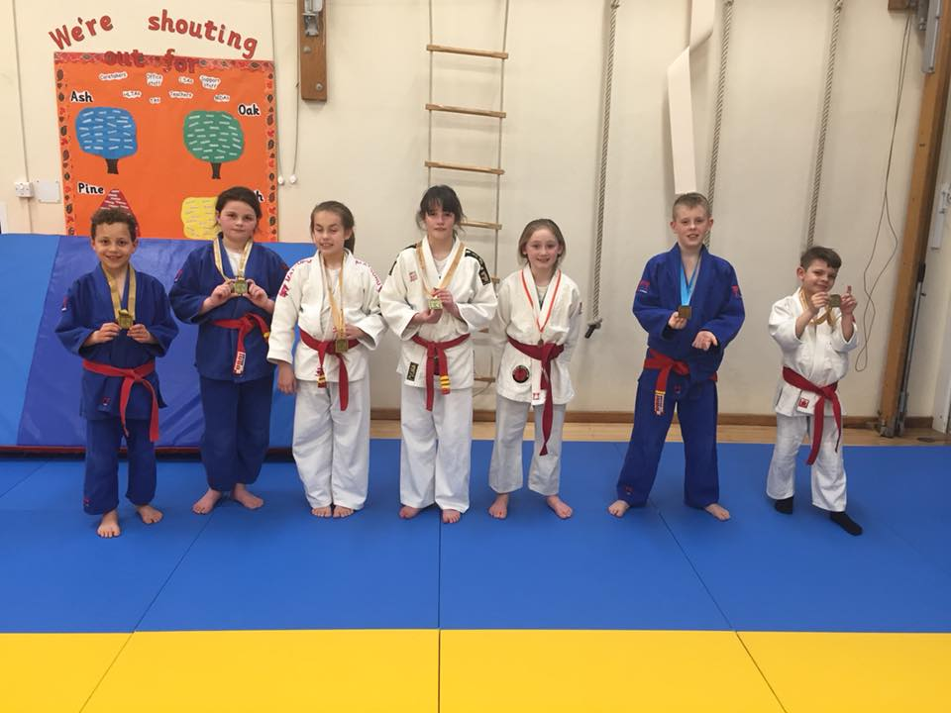

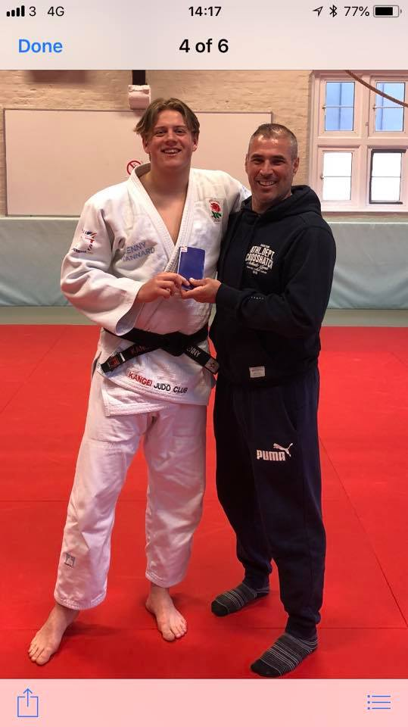[Gang of Three Regular](http://www.1001fonts.com/gang-of-three-font.html)

**April 18**

**Sunday 6th May** – Regional England Development Training

**Sunday 13th May** – 61 Judo Club Green Belt & Below

**Wednesday 16th May** - Lollypop grading will take place. Please make sure you have practiced.

**Saturday 19th May**– London Open 2018

**Saturday 26th May** – English Minors Open

GOOD LUCK!!!

**UPCOMING Competitions**

**Congratulations**

On Sunday 29th April Sensei Lenny Stannard (Kangei Judo Club Coach) attended the Budokwai and fought for his second Dan. Lenny has been competing at various gradings over the last few months to achieve his goal and had already got 80 points. Lenny needed 20 more points (equivalent to 2 ippon wins). He managed to secure his second Dan by beating one 1st Dan and one 2nd Dan at the budokwai which added to his other 80 points giving him his 100-point total. This is a massive achievement and we are all very proud of him.

**April 18**

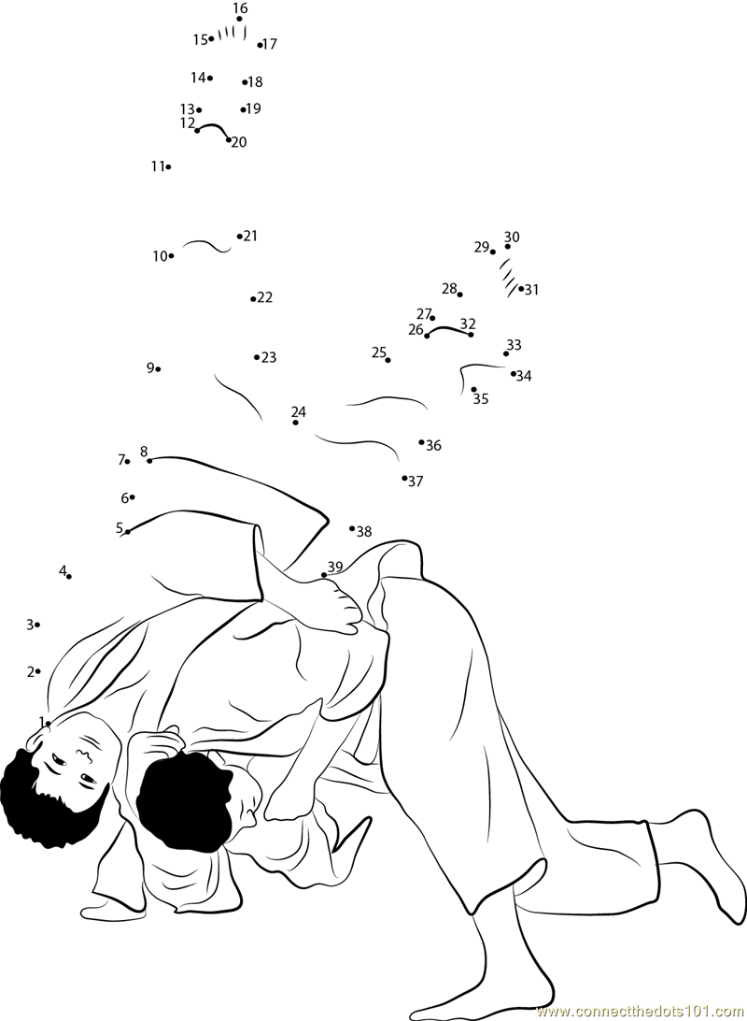



**Sonny Nicholas**

**Riley Dowson** – Participation Medal

**Sienna Thorne** – Participation Medal

**Harry Egleton** - Gold

**Sonny Nicholas**- Gold

**Courtney Johnson**- Gold

**Jessica Garrett**- Gold

**Chloe Allum**- Gold

**Peter Johnson** – Participation Medal

**Ellison Carr** – Bronze

**NHC Red Belt Rumble**

**Player of the month**

**SQUAD PROMOTIONS**

**Charlie Harris** - Black  
**Harvey Carr** - Blue  
**Ellison Carr** - Orange  
**Jessica Garrett** - Brown  
**Sophie Mooney** - Yellow  
**Courtney Johnson** - Green  
**Demi Argent** - Red  
**Sienna Thorne** - Red  
**Daniel Murray** - GOLD